Dataset 1:

<http://www.fao.org/faostat/en/?#data/QV>

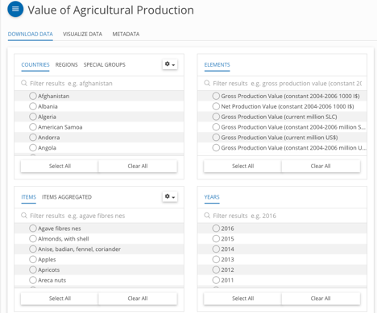

Production -> Value of Agricultural Production

2006-2016, all countries, all products

Gross production value(current million US)

Countries Items/items aggregated Gross production Value

-> page 5

-> map

Dataset 2:

<https://catalog.data.gov/dataset/supertracker-source-code-and-foods-database/resource/43a6f7fa-90e0-49be-9e8b-fe6fd5b4bd52>

SuperTrackerFoodDatabase.xlsx -> nutrients

-> Page 5

-> Spider chart

Dataset3:

<https://www.kaggle.com/c/whats-cooking/data>

Dish/what’s for dinner

-> Page 2 & 3

We looked at the dataset from the flavor network research paper also provided by Yummly but their dataset has fewer entries - 8,663 vs 39,774 and their dataset has cuisines that don’t map to a geographic area i.e. ‘kid-friendly’ or ‘barbeque’.

Dataset 4:

<http://www.fao.org/faostat/en/?#data/EI/visualize>

Energy/Emission

Heat map by food category

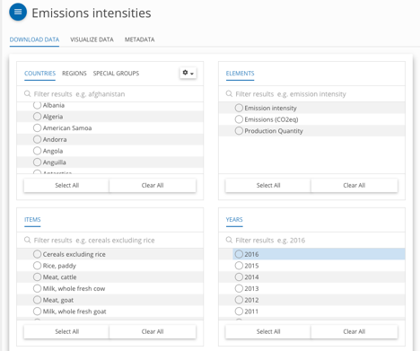

Agri-environment -> missions intensities.

Dataset 5:

<http://www.fao.org/faostat/en/?#data/FBS>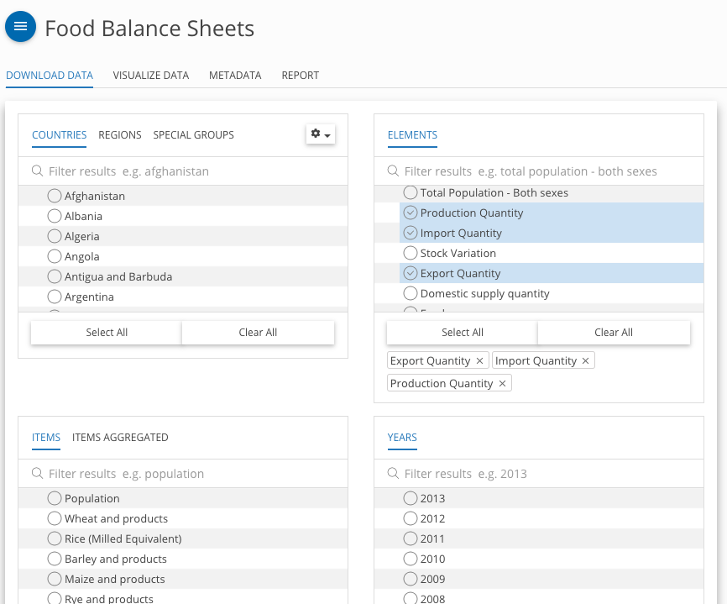

Food Balance -> Food balance sheet